**Programming Assignment02**

|  |
| --- |
| **Submission guide**  1. Write answer following questions in this file  2. Write your code using provided Jupyter notebook file   * Do not use other packages that are not already imported in the script * You have to complete several functions under description * Please check **TODO** * After completing your code, run script and submit with the printed results for answering questions in this word file |

1. Naïve Bayes (40pts)

(1) Complete uploaded python code. (20pts)

1. First, you have to binarize training set (trainX) of MAGIC Gamma Telescope data set. Each column is converted to binary variable based on the average value. If a value is greater than average, set a value as 1. Otherwise, set a value as 0. Then, using new binarized dataset, calculate $p_{ij}=P(x_{j}=1|y_{j}=i)$ ($i=class, j=feature)$. (5pts)

|  |  |  |
| --- | --- | --- |
|  | Class g | Class h |
| $$P(x_{1}=1)$$ | 0.28394812 | 0.46020179 |
| $$P(x_{2}=1)$$ | 0.26570734 | 0.39872945 |
| $$P(x_{3}=1)$$ | 0.40099311 | 0.47328102 |
| $$P(x_{4}=1)$$ | 0.44791244 | 0.46319133 |
| $$P(x_{5}=1)$$ | 0.43362383 | 0.45347534 |
| $$P(x_{6}=1)$$ | 0.66041751 | 0.52709268 |
| $$P(x_{7}=1)$$ | 0.61076206 | 0.50840807 |
| $$P(x_{8}=1)$$ | 0.50405351 | 0.49701046 |
| $$P(x_{9}=1)$$ | 0.23510336 | 0.67470105 |
| $$P(x_{10}=1)$$ | 0.46068099 | 0.53419283 |

(3) Based on the calculated $p_{ij}$, calculate probability of class g for each test sample (testX) and calculate accuracy for testX with varying cutoff (**To binarize testX, use the mean of trainX**). Prior probabilities of classes are proportional to ratios of classes in training set. cutoff ∈{0.1,0.15,0.2,0.25,…,0.95}. Draw a line plot (x=cutoff, y=accuracy). (10pts)

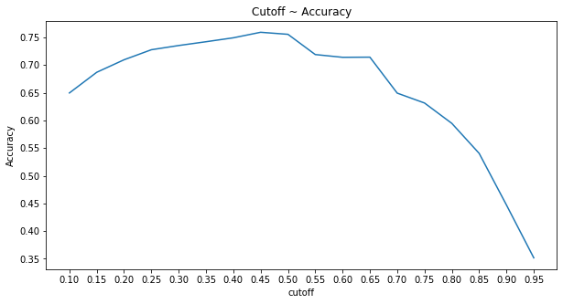

(4) Explain why the shape of figure of Question 1-(3) looks like this. (5pts)

Since P(y = ‘g’) is larger than 0.5, graph has shown tendency for starting around 65% accuracy, and as cutoff value approach to center, which is 0.50, Accuracy also increase at maximum which is similar with ordinal P(y = ‘g’ | x = 1). After getting to edge at cutoff 0.50, accuracy decline in large margin due to same reason for starting at 65%, which actual P(y = ‘g’) is larger than 0.5.

Because of those reason, we can also see sum of accuracy when cutoff is 0.1 and 0.95 is converged to 1.

2. Decision Tree (30pts)

The aim of the given data set is to predict annual income of people based on the following factors.

* age: the age of an individual
* capital-gain: capital gains for an individual
* capital-loss: capital loss for an individual
* hours-per-week: the hours an individual has reported to work per week
* sex: 1 if male, 0 if female
* native-country: 1 if USA, 0 if others
* workclass_[#]: 1 if an individual belongs to workclass # otherwise 0 (eg. Workclass_Private is 1 if an individual works for private companies)
* education_[#]: 1 if an individual’s education level is # otherwise 0(education level: Graduate > 4-year university > “<4-year university” > High school > “<High school” > Preschool)
* marital-status_[#] 1 if an individual’s marital status is # otherwise 0 (Married-civ-spouse corresponds to a civilian spouse while Married-AF-spouse is a spouse in the Armed Forces)
* occupation_[#]: 1 if an individual’s occupation is # otherwise 0.
* race_[#]: 1 if an individual’s race is #, otherwise 0

Target is ‘income’ (“>50K” or “<=50K”)

fnlwgt represents the number of people the census believes the entry represents, which is not used in training.

(1) Train a decision tree with the setting that max_depth=3, min_samples_split=100, min_samples_leaf=50 using entropy. Then, calculate overall accuracy, accuracy of class “>50K”, and accuracy of class “<=50K”. (5pts)

|  |  |  |
| --- | --- | --- |
| overall accuracy | accuracy of class “>50K” | accuracy of class “<=50K” |
| 0.7975454131128329 | 0.18980392156862744 | 0.9990896479972255 |

(2) Based on the answer of Question 2-(1), describe the limitations of the trained decision tree model. (5pts)

Since it chooses one parameter as decision tree, it doesn’t help but have tilted proportion.

(3) Draw the trained tree. (3pts)

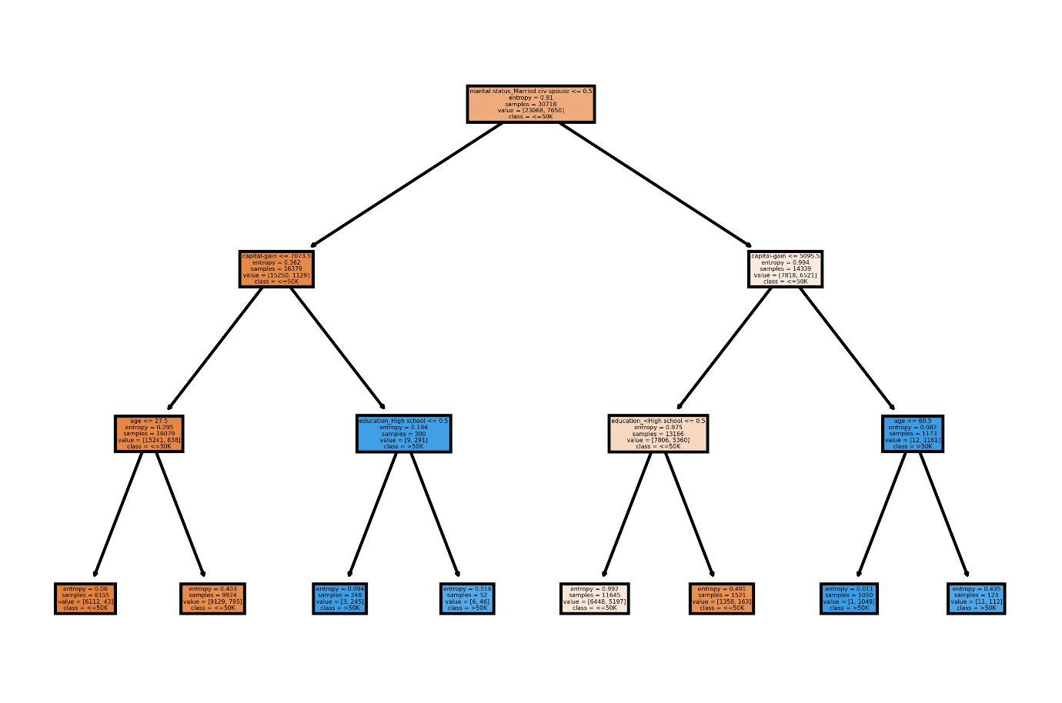

(4) Explain the rule for class “>50K” that contains the most cases. (3pts)

Martial-status_Married-civ-spouse <= 50

(5) Explain the rule for class “<=50K” that contains the most cases with an accuracy of 0.7 or higher. (3pts)

Age <= 60.5

Accuracy: 0.7511340420374667

(6) Train a new tree by changing a metric for finding split rules from entropy to gini impurity and compare two models in terms of the performance of the models and the generated rules (10pts)

By entropy:

Criterion: gini;

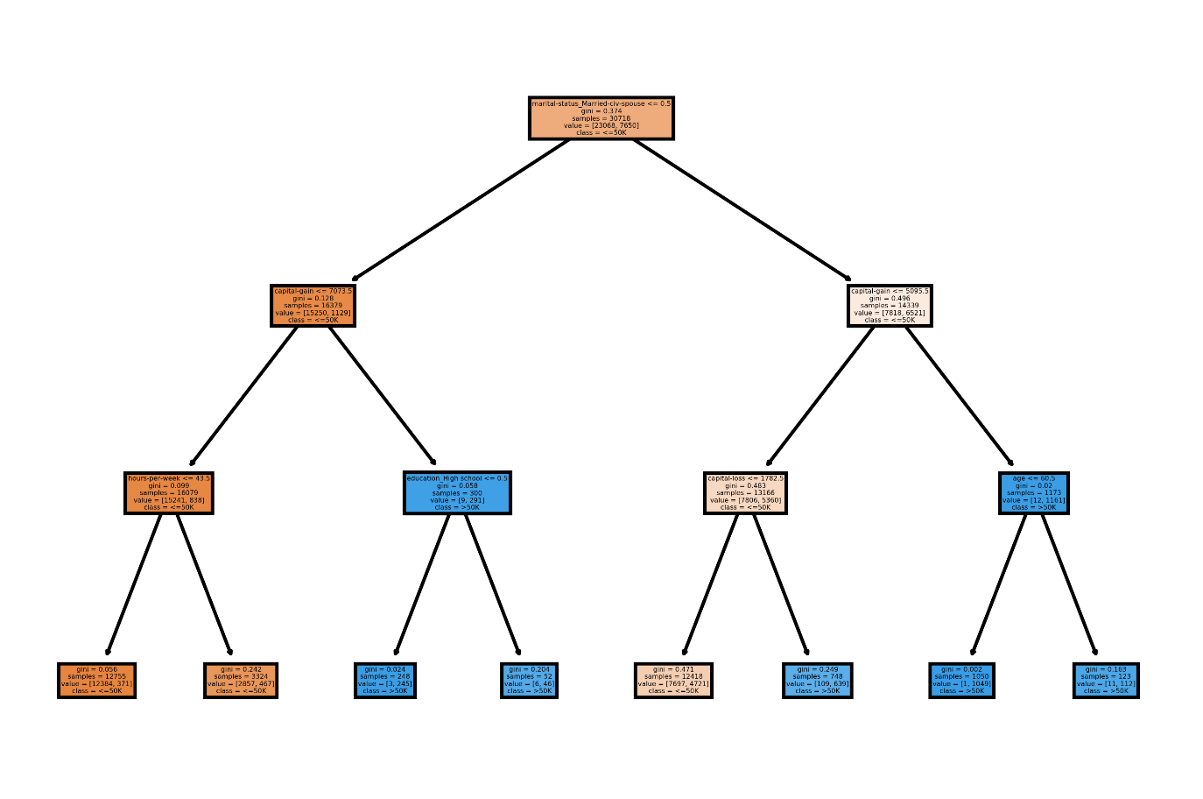

|  |  |  |
| --- | --- | --- |
| overall accuracy | accuracy of class “>50K” | accuracy of class “<=50K” |
| 0.8147991405690475 | 0.2733333333333333 | 0.9943644876018727 |

It is undeniable that both trees choose Martial-status_Married-civ-spouse factor at depth=0, which is very main factor for distinguishing data. We can also notice that most of part is quite similar but still have some differentiated part.

Decision tree based on gini factor has bit more accurate performance than one with entropy. Unlike one with entropy chooses age and aducation_<High school factors for deciding at depth=2, one with gini chooses hours-per-week and capital-loss factors.

3. -means clustering (30pts)

This problem uses the data generated from 4 normal distributions for applying $k$-means clustering.

k-means implemented in sci-kit learn can assign initial centroids through ‘init’. When init is set as $c$ by $p$ array ( $c$ = the number of clusters, $p$ = the number of features), each row is used as a centroid.

Ref: <https://scikit-learn.org/stable/modules/generated/sklearn.cluster.KMeans.html>

(1) Select randomly 4 samples from the given data set and use them as initial centroids. This procedure is repeated for 100 times. Then, calculate the average values of the silhouette coefficient and adjusted rand index values for 100 iteration. (5pts)

|  |  |
| --- | --- |
| silhouette coefficient | adjusted rand index |
| 0.5551464561031652 | 0.8484055630640407 |

(2) Select randomly one sample from each normal distribution and use them as initial centroids. This procedure is repeated for 100 times. Then, calculate the average values of the silhouette coefficient and adjusted rand index values for 100 iteration. (5pts)

|  |  |
| --- | --- |
| silhouette coefficient | adjusted rand index |
| 0.5928571337258896 | 0.9403513248097073 |

(3) Draw scatter plots for the given data with initial centroids and final centroids for the worst cases among 100 trials in Question 3-(1) in terms of silhouette coefficient and adjusted rand index, respectively. The initial centroids should be marked as red ‘X’ and the final centroids should be marked as blue ‘X’. (5pts)

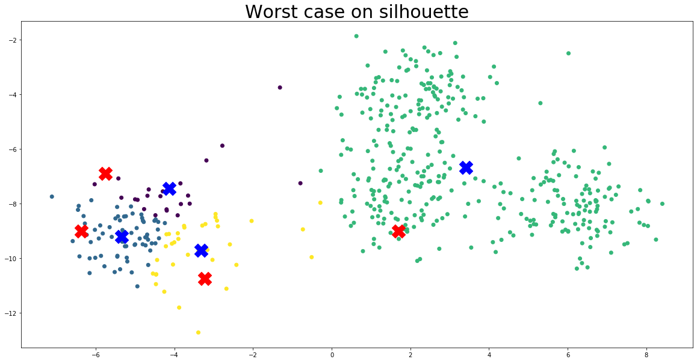

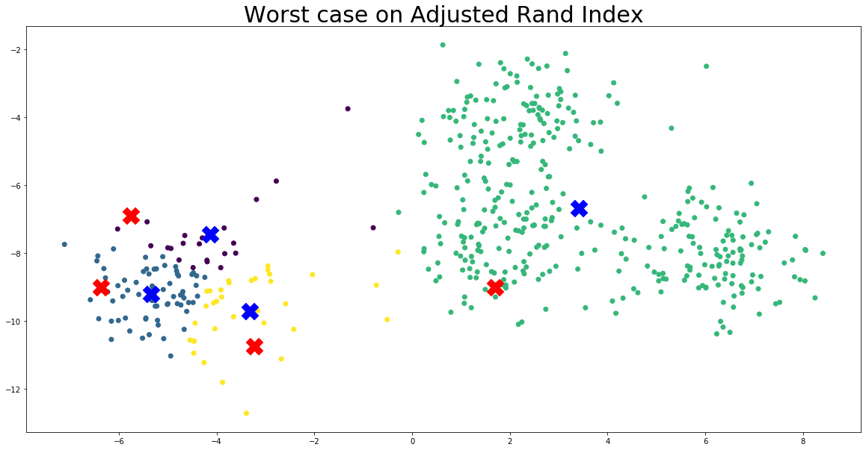

(4) Draw scatter plots for the worst case of Question 3-(2) in the same way as in Question 3-(3). (5pts)

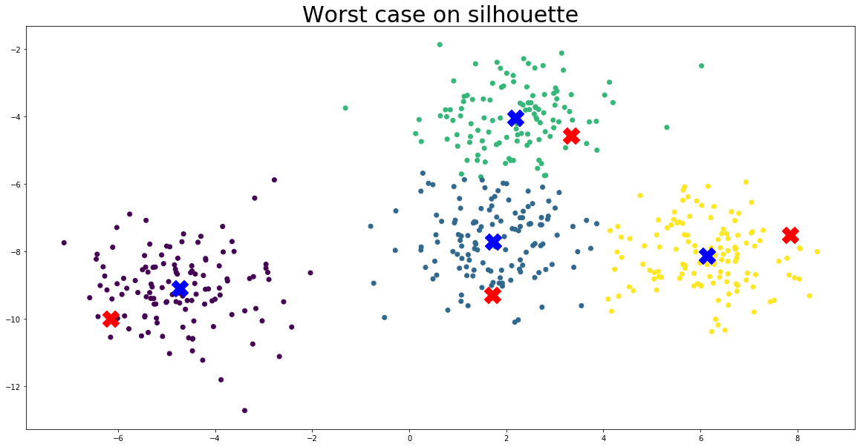

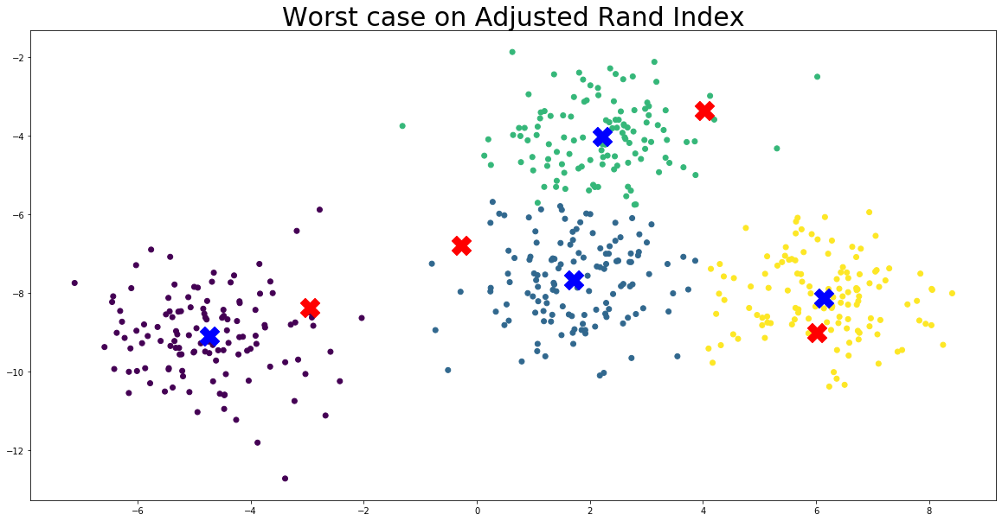

(5) Based on the different results from 100 trials for each case, compare two different methods to determine initial centroids. (10pts)

By comparing these two different results, we can easily notice that setting initial centroids effect huge impact to whole result. Also, it seems more accurate and efficient to choose random centroid in differentiated groups by each than complete random.

In conclusion, it will get better result to choose random centroid for each clusters than complete random.